* The history of physical address is recorded. They are recorded as locations.
* Identify shareholders from companies and persons
* Keep track of the person who hide behind ,but manipulate the company by " the agent"

e.g.Mave is banned from holding share in 2Degree company.

Now the clue can be found:

1. **The history of physical address is recorded. They are recorded as locations**.

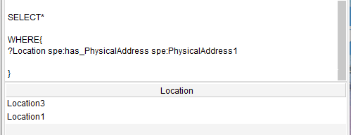

1. **Identify shareholders from companies and persons**

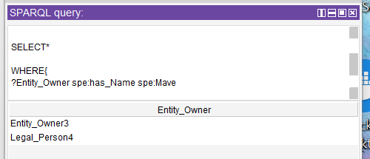

Mave is a person and is a shareholder

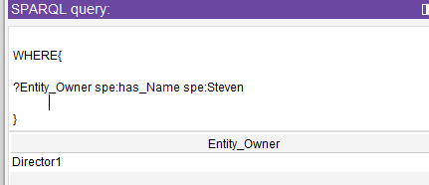

Steven is a person and is NOT a shareholder.

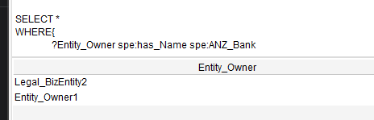

ANZ bank is a company and is a share holder.

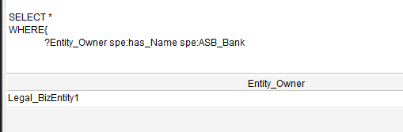

ASB bank is a company, and is NOT a shareholder

1. **Keep track of the person who hide behind ,but manipulate the company by " the agent"**

e.g.Mave is banned from holding share in 2Degree company.

To check if Mave violate this rule:

The checking can start from two ends

From 2Degree end:

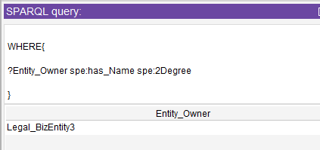

2 Degree is a company , is not a shareholder

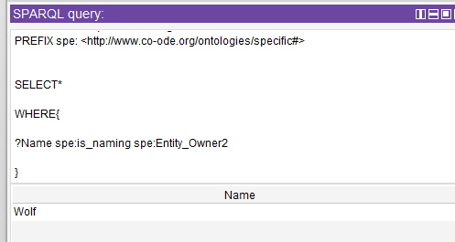

2Degree has a shareholder “Wolf”

From Mave side:



Mave is a business person and is a shareholder

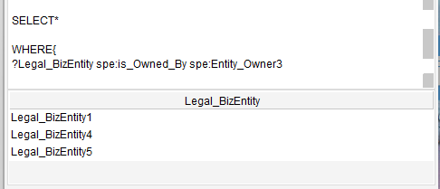

Mave owned 3 companies

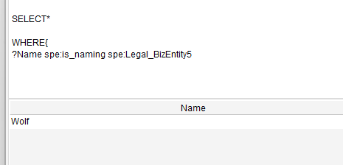

Mave owns a company “Wolf”

**Wolf is the connecting point between 2Degree and Mave.**

**As a result, we know Mave violated the rule.**